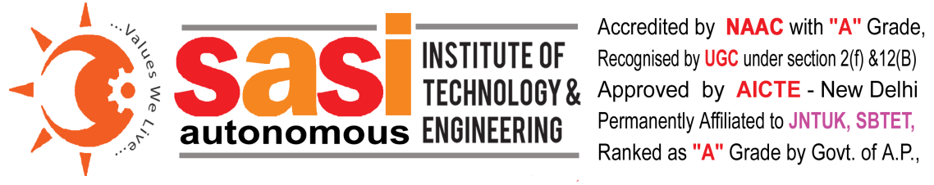
AP EAPCET 2021 - Category-B NRI Quota Admissions
Category-B NRI Quota admissions will be conducted for 15% of the intake of the courses AI&ML (9), Civil (9), CSE (27), CST (9), ECE (27), ECT (9), EEE (18), IT (9) and ME (18). These seats will be filled by the college with a Tuition Fee of US $5000 per Annum as per the guidelines issued by the Secretary, APSCHE.
The eligible candidates are required to submit the application form available at www.sasi.ac.in along with original certificates and two sets of all certificate photo copies on or before 15.09.2021 (Wednesday).

Principal Secretary & Correspondent

